
Over 16’s Family doctor services registration GMS1

Patient’s details |  |  |  |  | Please complete in BLOCK CAPITALS and tick | as appropriate
Mr Mrs Miss Ms Surname________________________________
Date of birth _____/________/_________ Previous Surname/s_______________________
First Name_______________________________
NHS No____________________________ Male Female
Home Address

Postcode
Town and country of birth _________________________________________________________
Previous address if applicable
Home No________________________________
Mobile No_______________________________
Email Address____________________________ ________________________________________

If you have moved to U.K from another country
Next of Kin details
Name:
Relationship to you:
Telephone No:
First UK Address where registered with a GP:

If previous resident of UK, date of leaving:

Date you first came to live in the UK:
Previous Doctors Information
Previous Doctor Name
Address

Were you ever registered with an Armed Forces GP
Please indicate if you have served in the UK Armed Forces and/or been registered with a Ministry of Defence GP in the UK or overseas:
Regular Reservist Veteran Family Member

What Armed Forces were you involved with?
Army Military Royal Navy Royal Marines RAF

Address before enlisting____________________________________________________________
_______________________________________________Post Code_________________________
Service or Personnel No __________________________Discharge Date _____________________
(These questions are optional and your answers will not affect your entitlement to register or receive services from the NHS but may improve access to some NHS priority and charities services.

Over 16’s Family doctor services registration

Ethnic Origin
White (British) | White  (Irish) | White  (other) | Caribbean | African | Asian | Other Mixed Background
Indian | Pakistani | Bangladeshi | Chinese | Other Black background | Other Asian background | Not Stated
Language spoken/understood
English | French | German | Polish | Hindi | Punjabi | Spanish
Ukranian | Bengali | Urdu | Other please specify_________________________
Do you require help from a Translator/Interpreter? Yes No
Church of England | Catholic | Other Christian | Buddhist | Sikh | Hindu | No Religion
Jewish | Jehovah’s Witness | Muslim | Other please specify  ________________
Religion

Specific Needs
Please state any allergies and sensitivities you have_______________________________
____________________________________________________________________________
____________________________________________________________________________

Please state if you have any Physical, Mental or Sensory disabilities _________________ ____________________________________________________________________________
____________________________________________________________________________
Over 16’s Family doctor ser
Are you an ‘Assistance Dog’ user? Yes No

Have you ever had a social worker involved with your family? If so when?
_______________________________________________________________________________
_______________________________________________________________________________
Are you a Carer? Yes No Do you have a Carer? Yes No
Person cared for Contact details: Carer’s Contact details:

Are you currently housebound (where you are unable to leave the house due to medical conditions)? Yes No
Do you have a “Living Will” (a statement explaining what medical treatment you would not want to receive in the future? Yes No
Family doctor services registration GMS1

Smoking
Are you a currently a smoker? | Yes | No | Have you ever been a smoker? | Yes | No | How many tobacco products do you smoker per day? | Quantity
Do you use electronic cigarettes? | Yes | No | Would you like information to help you on ‘Quit Smoking’ | Yes | No

Your Height ________Feet_________ inches or ___________________cm

Your Weight ________stone_________ pounds or __________________kg

Alcohol
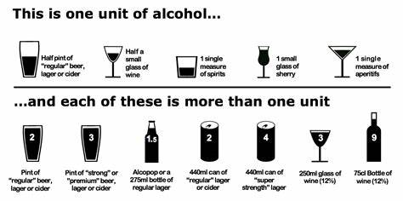

Questions | Scoring system |  |  |  |  |  | Your Score
Questions | 0 | 1 | 2 | 3 |  | 4 | Your Score
How often do you have an alcoholic drink? | Never | Monthly or less | 2-4 times a month | 2-3 per week |  | 4+ times per week
Howe many units of alcohol do you drink on a typical day when drinking? | 1-2 | 3-4 | 5-6 | 7-9 |  | 10+
How often have you had 6 pr more units if female, or 8 or more if male, on a single occasion in the last year? | Never | Less than monthly | Monthly | Weekly |  | Daily or almost daily
A total of 5+ indicates increased or higher risk drinking. If you scored 5 or more consider making an appointment to discuss this with the nurse. Would you like an appointment to discuss this further? |  |  |  | Yes | No | Total Score =

Electronic Prescribing

Please state a nominated pharmacy for your prescriptions to be sent electronically to

Name of Pharmacy____________________________Telephone_________________________
Address_______________________________________________________________________
______________________________________________________________________________

Would you like to order your prescriptions online? Yes No

If you would like to opt out of the Summary care Record please sign to confirm.  Summary Care Records are an electronic record of important patient information, created from GP medical records. They can be seen and used by authorised staff in other areas of the heath and care system involved in the patients direct care. | Please sign to confirm:

As a Practice we are committed to improving the services we provide to our patients. To do this, it is vital we hear from people about their experiences, views, and ideas for improving our services. You can do this by visiting our website and having your say by clicking on Patient Participation.
If you would like somebody else to speak about your medical records on your behalf, please complete the following:
Person’s name_____________________ Contact Number____________________________

Relation to you_____________________ Signed (by yourself)_________________________

Signature of Patient Signature on behalf of patient Date

______________________ ____________________________ ________________

Registration form Received by: |  |  | Today’s Date:
ID Checked (staff use only)

Over 16’s Family doctor services registration

Over 16’s Family doctor services registration

To be completed by the GP Practice

 | Practice Name | Practice Code

I have accepted this patient for general medical services on behalf of the practice

I declare to the best of my belief this information is correct |  |  | Practice Stamp
Authorised Signature | __________________________
 | __________________________
  Name | __________________________
Date | _________________________


SUPPLEMENTARY QUESTIONS - These questions and the patient declaration are optional and your answers will not affect your entitlement to register or receive services from your GP.

PATIENT DECLARATION for all patients who are not ordinarily resident in the UK

Anybody in England can register with a GP practice and receive free medical care from that practice.

However, if you are not ‘ordinarily resident’ in the UK you may have to pay for NHS treatment outside of the GP practice. Being ordinarily resident broadly means living lawfully in the UK on a properly settled basis for the time being. In most cases, nationals of countries outside the European Economic Area must also have the status of ‘indefinite leave to remain’ in the UK.

Some services, such as diagnostic tests of suspected infectious diseases and any treatment of those diseases are free of charge to all people, while some groups who are not ordinarily resident here are exempt from all treatment charges.

More information on ordinary residence, exemptions and paying for NHS services can be found in the Visitor and Migrant patient leaflet, available from your GP practice.

You may be asked to provide proof of entitlement in order to receive free NHS treatment outside of the GP practice, otherwise you may be charged for your treatment. Even if you have to pay for a service, you will always be provided with any immediately necessary or urgent treatment, regardless of advance payment.

The information you give on this form will be used to assist in identifying your chargeable status, and may be shared, including with NHS secondary care organisations (e.g. hospitals) and NHS Digital, for the purposes of validation, invoicing and cost recovery. You may be contacted on behalf of the NHS to confirm any details you have provided.

Please tick one of the following boxes:

a) I understand that I may need to pay for NHS treatment outside of the GP practice

b) | I understand I have a valid exemption from paying for NHS treatment outside of the GP practice. This includes for

example, an EHIC, or payment of the Immigration Health Charge (“the Surcharge”), when accompanied by a valid visa. I can provide documents to support this when requested

c) I do not know my chargeable status

I declare that the information I give on this form is correct and complete. I understand that if it is not correct, appropriate action may be taken against me.

A parent/guardian should complete the form on behalf of a child under 16.

Signed: |  | Date: | DD MM YY
Print name: |  | Relationship to
On behalf of: |  | patient:
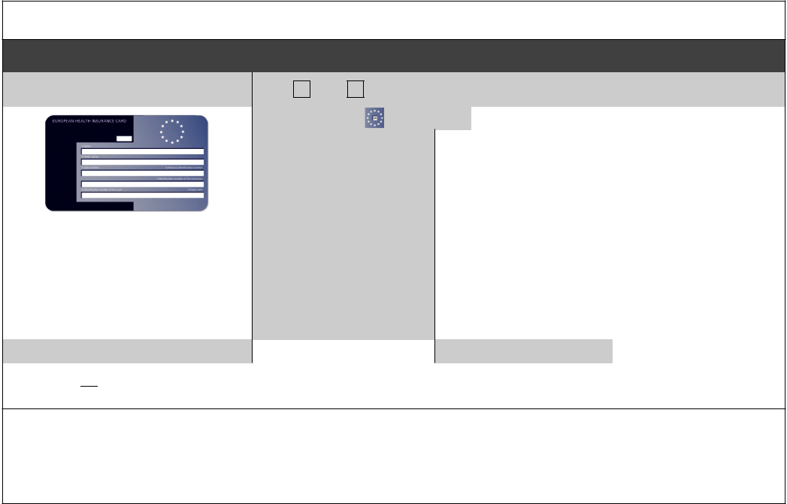

Complete this section if you live in another EEA country, or have moved to the UK to study or retire, or if you live in the UK but work in another EEA member state. Do not complete this section if you have an EHIC issued by the UK.

NON-UK EUROPEAN HEALTH INSURANCE CARD (EHIC), PROVISIONAL REPLACEMENT CERTIFICATE (PRC)

DETAILS and S1 FORMS

Do you have a non-UK EHIC or PRC? |  |  | YES: | NO: | If yes, please enter details from your EHIC or
 |  |  | YES: | NO: | PRC below:
 |  |  | Country Code:

 |  | 3: Name
 |  | 4: Given Names
 |  | 5: Date of Birth | DD MM YYYY
 |  | 6: Personal Identification
If you are visiting from another EEA |  | Number
country and do not hold a current |  | 7: Identification | number
EHIC (or Provisional Replacement |  | of the institution
Certificate (PRC))/S1, you may be billed
 |  | 8: Identification | number
for the cost of any treatment received |  | 8: Identification
 |  | of the card
outside of the GP practice, including |  | of the card
at a hospital. |  | 9: Expiry Date | DD MM YYYY
PRC validity period | (a) From: | DD MM YYYY | (b) To: | DD MM YYYY

Please tick if you have an S1 (e.g. you are retiring to the UK or you have been posted here by your employer for work or you live in the UK but work in another EEA member state). Please give your S1 form to the practice staff.

How will your EHIC/PRC/S1 data be used? By using your EHIC or PRC for NHS treatment costs your EHIC or PRC data and GP appointment data will be shared with NHS secondary care (hospitals) and NHS Digital solely for the purposes of
cost recovery. Your clinical data will not be shared in the cost recovery process.

Your EHIC, PRC or S1 information will be shared with The Department for Work and Pensions for the purpose of recovering your NHS costs from your home country.

TEXT AND/OR VIDEO COMMUNICATION CONSENT FORM
Declaration
- I consent to the Practice contacting me by text message and/or video call for the purposes of health advice and information regarding appointments.

- I understand the SMS service should not be solely relied upon, as the responsibility for attending and cancelling appointments rest with me.

- Text messages are generated using a secure facility, but I understand that they are transmitted over a public network on to a personal telephone.

- I will keep the Practice informed of my up to date mobile number at all times, informing the Practice if the number is no longer in my possession.

Please note
The Practice will NOT send out any text messages unless you have explicitly consented by completing this form. For more information about the services we offer, please visit our website
http://www.harboroughfieldsurgery.nhs.net/

PATIENT NAME:
DATE OF BIRTH:
MOBILE TELEPHONE NUMBER: | (IF MORE THAN ONE PERSON SHARES THIS NUMBER, WE WILL NEED A CONSENT FORM FROM EACH INDIVIDUAL)
SIGNATURE:
TODAYS DATE:
*The Practice will not share your mobile telephone number with any third-party companies.

